A Project Report
on
FASHION STORE MANAGEMENT System
For AISSCE 2020 Examination
[As a part of the Informatics Practices Course (065)]
SUBMITTED BY: -
NAME: _________________
rOLLnO.:_________________
Under the Guidance of: Ms.Honey Kaur
PGT (Comp.Sc)

CERTIFICATE

This is to certify that the Project / Dissertation entitled FASHION STORE MANAGEMENT System is a bonafide work done by ____________________ of class XII Session 2019-20 in partial fulfillment of CBSE’s AISSCE Examination 2020 and has been carried out under my direct supervision and guidance. This report or a similar report on the topic has not been submitted for any other examination and does not form a part of any other course undergone by the candidate.

………………………… ……………………………..

Signature of Student Signature of Teacher/Guide

Name: Name: Ms.Honey Kaur
Roll No.: Design.: PGTComp.Sc.

ACKNOWLEDGEMENT
I
, undertook this Project work, as the part of my XII-Informatics Practices course(065). I had tried to apply my best of knowledge and experience, gained during the study and class work experience. However, developing software system is generally a quite complex and time-consuming process. It requires a systematic study, insight vision and professional approach during the design and development. Moreover, the developer always feels the need, the help and good wishes of the people near you, who have considerable experience and idea.
I would like to extend my sincere thanks and gratitude to my teacher
Ms. Honey Kaur , for giving valuable time and moral support to develop this software.
I also feel indebted to my friends for the valuable suggestions during the project work.

_______________

Class XII

C O N T E N T S

1. Introduction 5
2. Objective & Scope of the Project 7
3. System Implementation 9
3.1 The Hardware used: 9
3.2 The Softwares used: 9
4. Theoretical Background------------------------------------10
4.1 What is Database? -------------------------------------------------10
4.2 What is MySQL?-----------------------------------------------------12
4.3 What is Python? ----------------------------------------------------14
5. System Design & Development ------17
5.1 Database Design: 17
5.2 Event Coding: 20
6. Output------------------------------------------------------------------------30
7. User Manual 40
7.1 How to install: 40
7.2 Working with Software: 40
8. References 42

1. Introduction

This software project is developed to automate the functionalities of a FASHION STORE MANAGEMENT SYSTEM.
The purpose of the software project is to develop the Management Information System (MIS) to automate the record keeping of products, purcahses , stock and sales transactions with a view to enhance the decision making of the functionaries.
A MIS mainly consists of a computerized database, a collection of inter-related tables for a particular subject or purpose like reference of product_id in all tables , capable to produce different reports relevant to the user. An application program is tied with the database for easy access and interface to the database. Using Application program(Python) or front-end, we can store, retrieve and manage all information in proper way.
This software, being simple in design and working, does not require much of training to users, and can be used as a powerful tool for automating a FASHION STORE MANAGEMENT SYSTEM.
During coding and design of the software Project, Python IDLE, as a powerful front-end tool is used for getting Graphical User Interface (GUI) based integrated platform and coding simplicity. As a back-end a powerful, open source RDBMS, MySQL is used as per requirement of the CBSE curriculum of Informatics Practices Course(065).

2. Objective & Scope of the Project
T

he objective of the software project is to develop a computerized MIS to automate the functions of a FASHION STORE MANAGEMENT SYSTEM. This software project is also aimed to enhance the current record keeping system, which will help managers to retrieve the up-to-date information at right time in right shape.
The proposed software system is expected to do the following functionality-
- To provide a user friendly, Graphical User Interface (GUI) based integrated and centralized environment for MIS activities.
- The proposed system should maintain all the records and transactions, and should generate the required reports and information when required.
- To provide graphical and user-friendly interface to interact with a centralized database based on client-server architecture.
- To identify the critical operation procedure and possibilities of simplification using modern IT tools and practices.
In its current scope, the software enables user to retrieve and update the information from centralized database designed with MySQL . This software does not require much training time of the users due to limited functionality and simplicity.
During the development of FASHION STORE MANAGEMENT SYSTEM project, Python IDLE, a powerful, open source event-driven form-based development environment is used for modular design and future expandability of the system.
Despite of the best effort of the developer, the following limitations and functional boundaries are visible, which limits the scope of this application software.
- This software can store records and produce reports in pre-designed format in soft copy. There is no facility yet to produce customized reports. Only specified reports are covered.
- There is no provision to calculate profit or loss etc. for the store; however it can be developed easily with the help of adding modules.
- It facilitates manager to record and update only transaction record.
So far as future scope of the project is concerned, firstly it is open to any modular expansion i.e. other modules or functions can be designed and embedded to handle the user need in future. Any part of the software and reports can be modified independently without much effort.

3. System Implementation

3.1 The Hardware used:
While developing the system, the used hardware are:
PC with Intel Core i5-2400S processor having 4.00 GB RAM, 64-bit Operating System , SVGA and other required devices.

3.2 The Softwares used:
- Microsoft Windows® 10 Pro as Operating System.
- Python 3.7.2 as Front-end Development environment.
- MySQL as Back-end Sever with Database for Testing.
- Mysql.connector to connect Python module with database.
- MS-Word 2010 for documentation.

4. Theoretical Background

4.1 What is Database?

Introduction and Concepts:
A database is a collection of information related to a particular subject or purpose, such as tracking customer orders or maintaining a music collection. Using any RDBMS application software like MS SQL Server, MySQL, Oracle, Sybase etc, you can manage all your information from a single database file. Within the file, divide your data into separate storage containers called tables. You may and retrieve the data using queries.
A table is a collection of data about a specific topic, such as products or suppliers. Using a separate table for each topic means you can store that data only once, which makes your database more efficient and reduces data-entry errors. Table organises data into columns (called fields) and rows (called records).
A Primary key is one or more fields whose value or values uniquely identify each record in a table. In a relationship, a primary key is used to refer to specific record in one table from another table. A primary key is called foreign key when it is referred to from another table.
To find and retrieve just the data that meets conditions you specify, including data from multiple tables, create a query. A query can also update or delete multiple records at the same time, and perform built-in or custom calculations on your data.
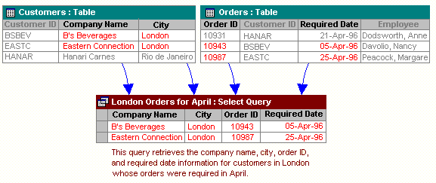

Role of RDBMS Application Program:
A computer database works as a electronic filing system, which has a large number of ways of cross-referencing, and this allows the user many different ways in which to re-organize and retrieve data. A database can handle business inventory, accounting and filing and use the information in its files to prepare summaries, estimates and other reports. The management of data in a database system is done by means of a general-purpose software package called a Database Management System (DBMS). Some commercially available DBMS are MS SQL Server, MS ACCESS, INGRES, ORACLE, and Sybase. A database management system, therefore, is a combination of hardware and software that can be used to set up and monitor a database, and can manage the updating and retrieval of database that has been stored in it. Most of the database management systems have the following capabilities:
- Creating of a table, addition, deletion, modification of records.
- Retrieving data collectively or selectively.
- The data stored can be sorted or indexed at the user's discretion and direction.
- Various reports can be produced from the system. These may be either standardized report or that may be specifically generated according to specific user definition.
- Mathematical functions can be performed and the data stored in the database can be manipulated with these functions to perform the desired calculations.
- To maintain data integrity and database use.
The DBMS interprets and processes users' requests to retrieve information from a database. In most cases, a query request will have to penetrate several layers of software in the DBMS and operating system before the physical database can be accessed. The DBMS responds to a query by invoking the appropriate subprograms, each of which performs its special function to interpret the query, or to locate the desired data in the database and present it in the desired order.

4.2 What is My SQL ? 
The management of data in a database system is done by means of a general-purpose software package called a Database Management System (DBMS). Some commercially available RDBMS are MS SQL Server, MS ACCESS, INGRES, ORACLE, and Sybase.
MySQL, the most popular Open Source SQL database management system, is developed, distributed, and supported by Oracle Corporation. MySQL is named after co-founder Monty Widenius's daughter, My. The name of the MySQL Dolphin (our logo) is “Sakila,”.
- MySQL is a database management system.
A database is a structured collection of data. It may be anything from a simple shopping list to a picture gallery or the vast amounts of information in a corporate network. To add, access, and process data stored in a computer database, you need a database management system such as MySQL Server. Since computers are very good at handling large amounts of data, database management systems play a central role in computing, as standalone utilities, or as parts of other applications.
- MySQL is based on SQL.
A relational database stores data in separate tables rather than putting all the data in one big storeroom. This adds speed and flexibility. The SQL part of “MySQL” stands for “Structured Query Language.” SQL is the most common standardized language used to access databases and is defined by the ANSI/ISO SQL Standard. The SQL standard has been evolving since 1986 and several versions exist. In this manual, “SQL-92” refers to the standard released in 1992, “SQL:1999” refers to the standard released in 1999, and “SQL:2003” refers to the current version of the standard.

- MySQL software is Open Source.
Open Source means that it is possible for anyone to use and modify the software. Anybody can download the MySQL software from the Internet and use it without paying anything. If you wish, you may study the source code and change it to suit your needs. The MySQL software uses the GPL (GNU General Public License),
- The MySQL Database Server is very fast, reliable, and easy to use.
If that is what you are looking for, you should give it a try. MySQL Server also has a practical set of features developed in close cooperation with our users. You can find a performance comparison of MySQL Server with other database managers on our benchmark page. MySQL Server was originally developed to handle large databases much faster than existing solutions and has been successfully used in highly demanding production environments for several years. Although under constant development, MySQL Server today offers a rich and useful set of functions. Its connectivity, speed, and security make MySQL Server highly suited for accessing databases on the Internet.
- MySQL Server works in client/server or embedded systems.
The MySQL Database Software is a client/server system that consists of a multi-threaded SQL server that supports different backends, several different client programs and libraries, administrative tools, and a wide range of application programming interfaces (APIs).

The Main Features of MySQL are :
- Written in C and C++.
- Works on many different platforms.
- Uses multi-layered server design with independent modules.
- Provides transactional and nontransactional storage engines.
- Designed to make it relatively easy to add other storage engines. This is useful if you want to provide an SQL interface for an in-house database.
- Uses a very fast thread-based memory allocation system.
- Executes very fast joins using an optimized nested-loop join.
- Implements SQL functions using a highly optimized class library that should be as fast as possible. Usually there is no memory allocation at all after query initialization.
- Provides the server as a separate program for use in a client/server networked environment, and as a library that can be embedded (linked) into standalone applications. Such applications can be used in isolation or in environments where no network is available.
- Password security by encryption of all password traffic when you connect to a server.
- Support for large databases. We use MySQL Server with databases that contain 50 million records. We also know of users who use MySQL Server with 200,000 tables and about 5,000,000,000 rows.
- MySQL client programs can be written in many languages. A client library written in C is available for clients written in C or C++, or for any language that provides C bindings.
- APIs for C, C++, Eiffel, Java, Perl, PHP, Python, Ruby, and Tcl are available, enabling MySQL clients to be written in many languages.
- The Connector/ODBC (MyODBC) interface provides MySQL support for client programs that use ODBC (Open Database Connectivity) connections.
- The Connector/J interface provides MySQL support for Java client programs that use JDBC connections. Clients can be run on Windows or Unix. Connector/J source is available.

4.3 What is Python ?
Python is an open source , object oriented high level programming language developed by Guido Van Rossum in 1991 at the National Research Institute for Mathematics,Netherlands.
Features of Python:
- It is an interactive ,interpreted language.
- It is a loosely typed object –oriented language.
- It is a free open –source and portable language,
- It takes less time to develop programs.
- It is extensible / extendable and highly efficient .
- It supports GUI.
- It can be easily compatible with other languages like C , C++ etc.
- It is used for both scientific and non-scientific programming.

Installing Python:
It can be installed by using website :
https://www.python.org/downloads/

Interacting with Python:
Python programs can be run in two ways:
- Using Command line window
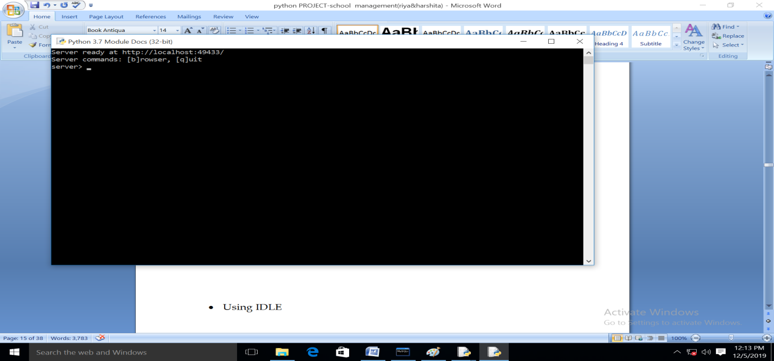

- Using IDLE
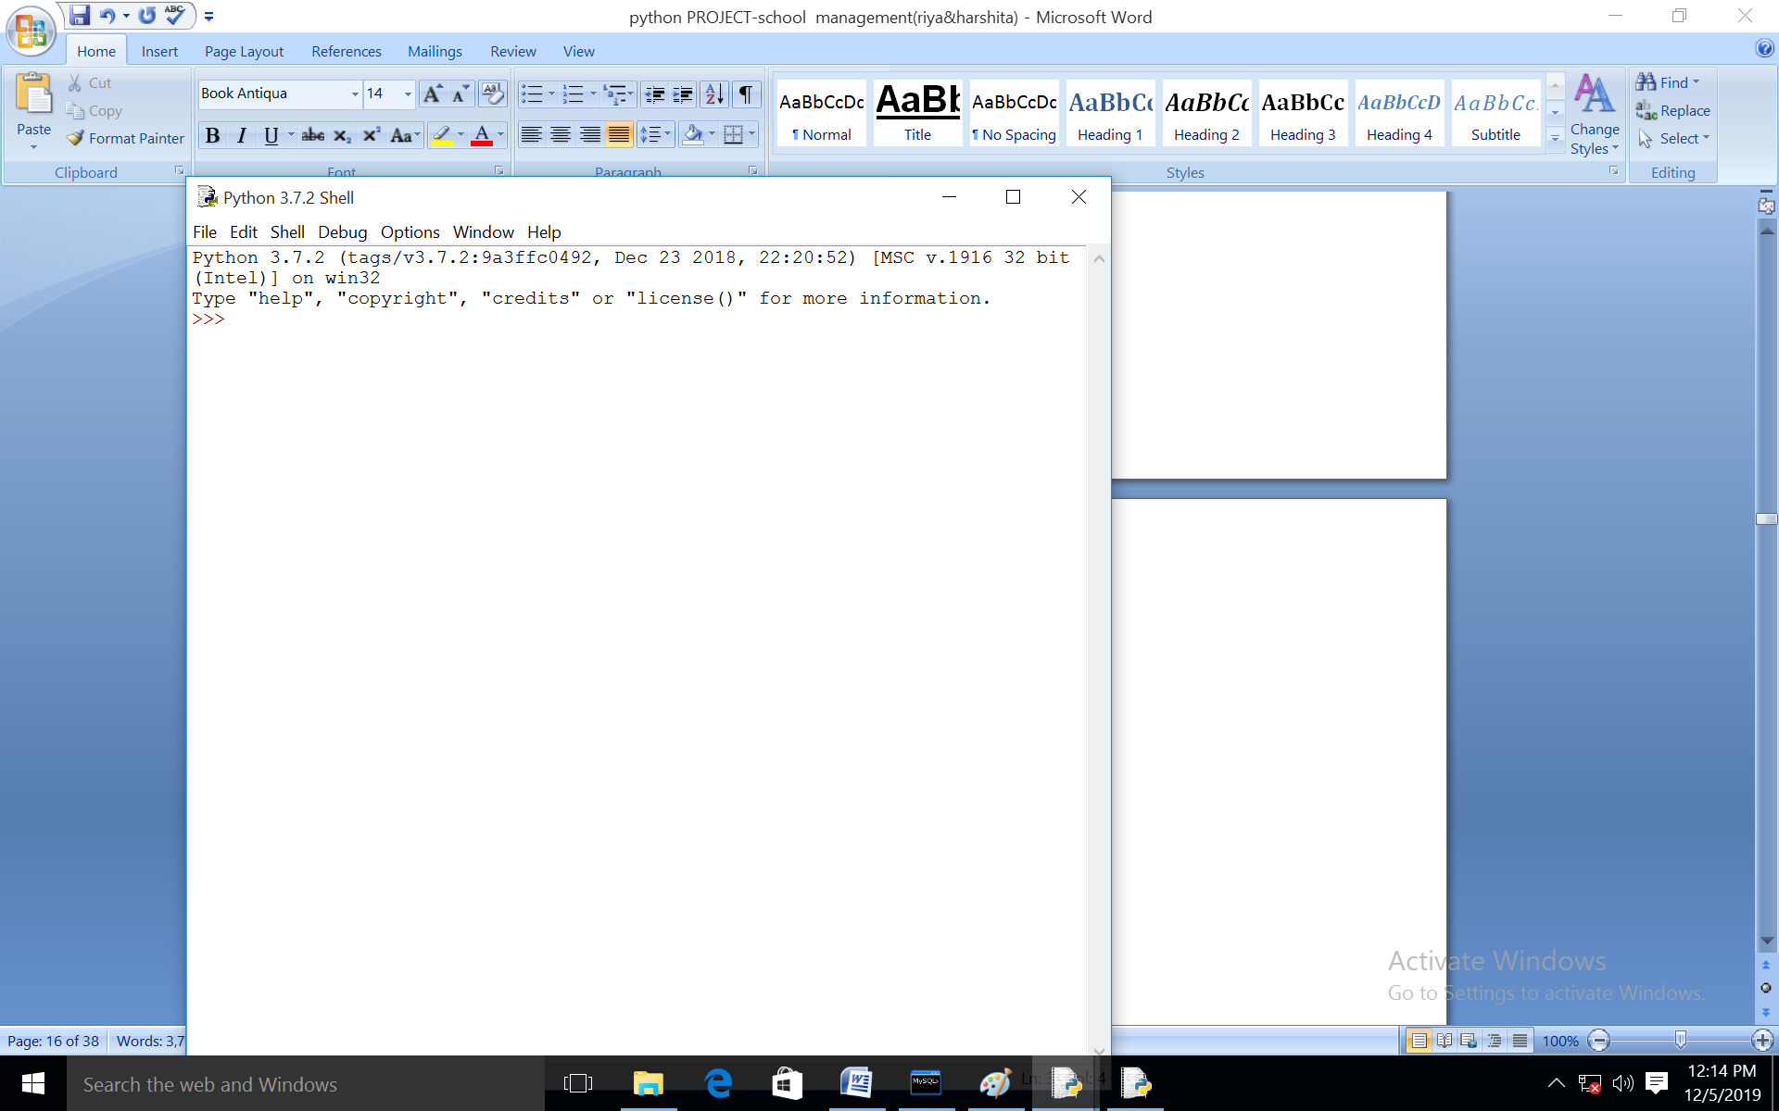

5. System Design & Development

5.1 Database Design:
An important aspect of system design is the design of data storage structure. To begin with a logical model of data structure is developed first. A database is a container object which contains tables, queries, reports and data validation policies enforcement rules or contraints etc. A logical data often represented as a records are kept in different tables after reducing anomalies and redundancies. The goodness of data base design lies in the table structure and its relationship.
This software project maintains a database named class12 which contains the following tables:

Table Design:
The database of FASHION STORE MANAGEMENT SYSTEM contains 4 tables in database Library. The tables are normalized to minimize the redundancies of data and enforcing the validation rules of the organization. Most of the tables are designed to store master records. The tables and their structure are given below:
DBMS: MySQL
Host: localhost , User: root , Pass: h , DataBase: class12

Table Structure: (Images Bellow)

Product Table:

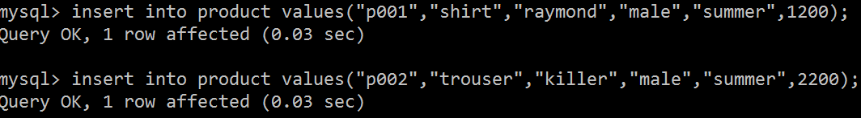

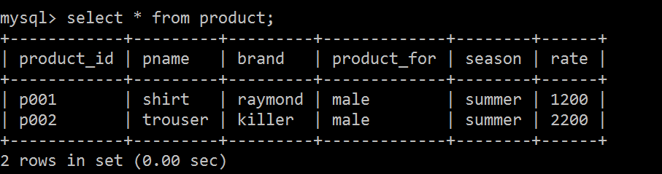

Purchase Table:

Note: In Purchase table take the purchase ID as varchar (16)

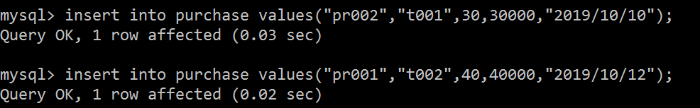

Stock Table

Sales Table:

Note: In Purchase table take the sale_id as varchar (16)

CODING

Python Code:

import os
import platform
import mysql.connector
import pandas as pd
import datetime
mydb=mysql.connector.connect(host="localhost",\
user="root",\
passwd="root",\
database="class12")
mycursor=mydb.cursor()

def AddProduct():
L=[]
stk=[]
pid=input("Enter the Product ID : ")
L.append(pid)
IName=input("Enter the Product Name : ") L.append(IName)
brnd=input("Enter the Product Brand Name : ")
L.append(brnd)
fr=input("Enter Male/Female/Kids : ")
L.append(fr)
sn=input("Enter Winter/Summer : ")
L.append(sn)
rate=int(input("Enter the Rates for Product :"))
L.append(rate)
product=(L)
sql="Insert into product (product_id,PName,brand,Product_for,Season,rate)values(%s,%s,%s,%s,%s,%s)"
mycursor.execute(sql,product)
mydb.commit()
stk.append(pid)
stk.append(0)
stk.append("No")
st=(stk)
sql="insert into stock(item_id, Instock, status) values(%s,%s,%s)"
mycursor.execute(sql,st)
mydb.commit()
print("One Product inserted ")

def EditProduct():
pid=input("Enter product ID to be edited : ")
sql="select * from product where product_id=%s"
ed=(pid,)
mycursor.execute(sql,ed)
res=mycursor.fetchall()
for x in res:
print(x)
print("")
fld=input("Enter the field which you want to edit : ")
val=input("Enter the value you want to set : ")
sql="Update product set " + fld +"='" + val + "' where product_id='" + pid + "'"
sq=sql
mycursor.execute(sql)
print("Editing Don : ")
print("After correction the record is : ")
sql="select * from product where product_id=%s"
ed=(pid,)
mycursor.execute(sql,ed)
res=mycursor.fetchall()
for x in res:
print(x)
mydb.commit()

def DelProduct():
pid=input("Enter the Product)id to be deleted : ")
sql="delete from sales where item_id=%s"
id=(pid,)
mycursor.execute(sql,id)
mydb.commit()
sql="delete from purchase where item_id=%s"
mycursor.execute(sql,id)
mydb.commit()
sql="delete from stock where item_id=%s"
mycursor.execute(sql,id)
mydb.commit()
sql="delete from product where product_id=%s"
mycursor.execute(sql,id)
mydb.commit()
print("One Item Deleted")

def ViewProduct():
print("Display Menu: Select the category to display the data")
print("1. All Details")
print("2. Product Name:")
print("3. Product Brand:")
print("4. Product For:")
print("5. Product Season:")
print("6. Product ID:")
x=0
ch=int(input("Enter your choice to display : "))
if ch==1:
sql="select * from product"
mycursor.execute(sql)
res=mycursor.fetchall()
for x in res:
print(x)
x=1
elif ch==2:
var='PName'
val=input("Enter the name of Product : ")
elif ch==3:
var='brand'
val=input("Enter the name of Brand : ")
elif ch==4:
var='Product_for'
val=input("Enter Male/Femal/Kids : ")
elif ch==5:
var='season'
val=input("Enter the Season : ")
elif ch==6:
var='product_id'
val=input("Enter the Product_id : ")
if x==0:
sql="select * from product where " + var + " = %s"
sq=sql
tp=(val,)
mycursor.execute(sq,tp)
res=mycursor.fetchall()
for x in res:
print(x)

def PurchaseProduct():
mn=""
dy=""
now=datetime.datetime.now()
purchaseID="P"+str(now.year)+str(now.month)+str(now.day)+str(now.hour)+str(no w.minute)+str(now.second)
L=[]
Lst=[]
L.append(purchaseID)
itemId=input("Enter Product ID : ")
L.append(itemId)
itemNo=int(input("Enter the number of Items : "))
L.append(itemNo)
sql="select rate from product where product_id=%s"
pid=(itemId,)
mycursor.execute(sql,pid)
res=mycursor.fetchone()
for x in res:
print("rate is : ", x)
amount=x*itemNo
print("Amount is :", amount)
L.append(amount)
mnth=now.month
if mnth<=9:
mn="0"+str(mnth)
else:
mn=str(mnth)
day=now.day
if day<=9:
dy="0"+str(day)
else:
dy=str(day)
dt=str(now.year)+"-"+mn+"-"+dy
L.append(dt)
tp=(L)
sql="insert into purchase(purchase_id,item_id,
no_of_items,amount,Purchase_date)values(%s,%s,%s,%s,%s)"
mycursor.execute(sql,tp)
mydb.commit()
sql="Select Instock from stock where item_id=%s"
mycursor.execute(sql,pid)
res=mycursor.fetchall()
status="No"
for x in res:
print(x)
instock=x[0]+itemNo
if instock>0:
status="Yes"
Lst.append(instock)
Lst.append(status)
Lst.append(itemId)
tp=(Lst)
sql="update stock set instock=%s,status=%s where item_id=%s"
mycursor.execute(sql,tp)
mydb.commit()
print("1 Item purchased and saved in Database")

def ViewPurchase():
item=input("Enter Product Name : ")
sql="select product.product_id, product.PName,product.brand, purchase.no_of_items, purchase.purchase_date, purchase.amount from product INNER JOIN purchase ON product.product_id=purchase.item_id and product.PName=%s"
itm=(item,)
mycursor.execute(sql,itm)
res=mycursor.fetchall()
for x in res:
print(x)

def ViewStock():
item=input("Enter Product Name : ")
sql="select product.product_id,product.PName,stock.Instock,\
stock.status from stock, product where \
product.product_id=stock.item_id and product.PName=%s"
itm=(item,)
mycursor.execute(sql,itm)
res=mycursor.fetchall()
for x in res:
print(x)
def SaleProduct():
now=datetime.datetime.now()
saleID="S"+str(now.year)+str(now.month)+str(now.day)+str(now.hour)+str(now.mi nute)+str(now.second)
L=[]
L.append(saleID)
itemId=input("Enter Product ID : ")
L.append(itemId)
itemNo=int(input("Enter the number of Items : "))
L.append(itemNo)
sql="select rate from product where product_id=%s"
pid=(itemId,)
mycursor.execute(sql,pid)
res=mycursor.fetchall()
for x in res:
print("The rate of item is :",x)
dis=int(input("Enter the discount : "))
saleRate=x[0]-(x[0]*dis/100)
L.append(saleRate)
amount=itemNo*saleRate
L.append(amount)
mnth=now.month
if mnth<=9:
mn="0"+str(mnth)
else:
mn=str(mnth)
day=now.day
if day<=9:
dy="0"+str(day)
else:
dy=str(day)
dt=str(now.year)+"-"+mn+"-"+dy
L.append(dt)
tp=(L)
sql="insert into sales (sale_id, item_id,no_of_item_sold,\
sale_rate,amount,date_of_sale) values(%s,%s,%s,%s,%s,%s)"
mycursor.execute(sql,tp)
mydb.commit()
sql="Select Instock from stock where item_id=%s"
mycursor.execute(sql,pid)
res=mycursor.fetchall()
for x in res:
print("Total Items in Stock are : ",x)
instock=x[0]-itemNo
if instock>0:
status="Yes"
tp=(instock,status,itemId)
sql="update stock set instock=%s,status=%s where item_id=%s"
print("Remaining Items in Stock are : ",instock)
mycursor.execute(sql,tp)
mydb.commit()

def ViewSales():
item=input("Enter Product Name : ")
sql="select product.product_id, product.PName,product.brand,\
sales.no_of_item_sold,sales.date_of_sale,sales.amount \
from sales, product where product.product_id=sales.item_id \
and product.PName=%s"
itm=(item,)
mycursor.execute(sql,itm)
res=mycursor.fetchall()
for x in res:
print(x)

def MenuSet(): #Function For The SFashion Store System
print("Enter 1 : To Add Product ")
print("Enter 2 : To Edit Product ")
print("Enter 3 : To Delete Product ")
print("Enter 4 : To View Product ")
print("Enter 5 : To Purchase Product")
print("Enter 6 : To View Purchases")
print("Enter 7 : To View Stock Detials")
print("Enter 8 : To Sale the item")
print("Enter 9 : To View Sales Detials")
try: #Using Exceptions For Validation
userInput = int(input("Please Select An Above Option: ")) #Will Take Input From User
except ValueError:
exit("\nHy! That's Not A Number") #Error Message
else:
print("\n") #Print New Line
if(userInput == 1):
AddProduct()
elif(userInput == 2):
EditProduct()
elif (userInput==3):
DelProduct()
elif (userInput==4):
ViewProduct()
elif (userInput==5):
PurchaseProduct()
elif (userInput==6):
ViewPurchase()
elif (userInput==7):
ViewStock()
elif (userInput==8):
SaleProduct()
elif (userInput==9):
ViewSales()
else:
print("Enter correct choice. . . ")
print("*"*80)
print("* * * * * * * Welcome to the Project of Fashion Store * * * * * * * ")
print("* * * * Developed by: Neha Tyagi, PGT CS, KV no. 5 Jaipur : * * * * ")
print("*"*80)
print("")
MenuSet()

def runAgain():
runAgn = input("\nwant To Run Again Y/n: ")
while(runAgn.lower() == 'y'):
if(platform.system() == "Windows"):
print(os.system('cls'))
else:
print(os.system('clear'))
MenuSet()
runAgn = input("\nwant To Run Again Y/n: ")
runAgain()

OUTPUT

Output: (Main Menu)

(Add Product)

(Edit Product)

(Delete Product)

(View Product)

(Purchase Product)

(View Purchase)

(View Stock Details)

(Sale Item)

(View Sales Details)

7. User Manual

7.1 How to Install Software:

Hardware Requirement-
- Intel Pentium/Celeron or similar processor based PC at Client/Server end.
- 128 MB RAM and 4GB HDD space (for Database) is desirable.
- Standard I/O devices like Keyboard and Mouse etc.
- Printer is needed for hard-copy reports.
- Local Area Network(LAN) is required for Client-Server Installation

Software Requirement-
- Windows 2000/XP OS is desirable.
- NetBeans Ver 5.1 or higher should be installed with JDK and JVM.
- MySQL Ver 6.1 with Library Database must be present at machine.

Database Installation-
The software project is distributed with a backup copy of a Database named LIBRARY with required tables. Some dummy records are present in the tables for testing purposes, which can be deleted before inserting real data. The project is shipped with manav.SQL file which installs a database and tables in the computer system.
Note: The PC must have MySQL server with user (root) and password (h) . If root password is any other password, it can be changed by running MySQL Server Instance Configure Wizard.
Start Program MySQL MySQL Server MySQL Server Instance Config Wizard
Provide current password of root and new password as “h” , this will change the root password.
To install a MySQL database from a dump file (faisal.sql) , simply follow the following steps.
Step 1: Copy the manav.sql file in C:\Program files\Mysql\MySql server 5.1\Bin folder.
Step 2: Open MySQL and type the following command to create the database named travelagency.
mysql> create database library;
Step 3: Open Command Window (Start Run cmd)
Step 4: Go to the following folder using CD command of DOS.
C:\Program files\Mysql\MySql server 5.1\Bin>
Step 5: type the following command on above prompt -
C:….\bin> mysql -u root -pmanav library <manav.sql
This will create a library database with required tables.

8.References

In order to work on this project titled – FASHION STORE MANAGEMENT SYSTEM, the following books and literature are referred by me during the various phases of development of the project:
(1) The Complete Reference Python 3.7
-by Shildit
- MySQL, Black Book
-by Steven Holzner
(2) Understanding SQL
– Gruber
(3) http://www.mysql.org/
(4) http://www.python.org/
(5) On-line Help of Python ®
(6) Informatics Practices for class XII
-by Sumita Arora
(7) Together with Informatics Practices
(6) Various Websites of Discussion Forum and software development activities.

Other than the above-mentioned books, the suggestions and supervision of my teacher and my classmates also helped me to develop this software project.

